Coding in Arduino:
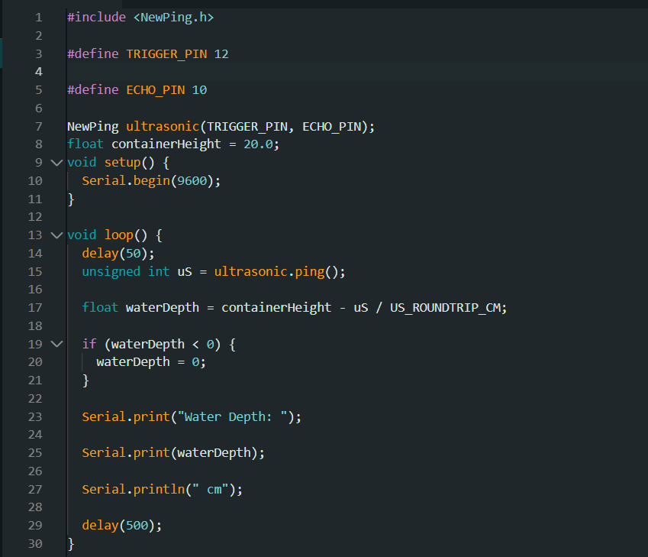
Basic elements of the code:
HC-SR04 Ultrasonic Sensor
Arduino
NewPing Library
HC-SR04 Ultrasonic Sensor:
Consists of a Trigger pin and an Echo pin.
Trigger Pin: Emits an ultrasonic pulse when activated.
Echo Pin: Listens for the echo, which is the reflected sound wave.
Basic overview of the code:
The distance travelled (that is, the distance between the water surface and the top of the ultrasonic sensor) is measured by sending a ping into the container. Microcontroller then processes the data received after each ping, and converts it into distance.

#include <NewPing.h>: Includes the NewPing library, which simplifies the handling of the HC-SR04 sensor.
#define TRIGGER_PIN 12: Defines pin 12 as the Trigger Pin.
#define ECHO_PIN 10: Defines pin 10 as the Echo Pin
NewPing ultrasonic(TRIGGER_PIN, ECHO_PIN);
- NewPing ultrasonic(TRIGGER_PIN, ECHO_PIN): Creates an instance of the NewPing object called ultrasonic with the trigger and echo pins.
- This instance will be used to measure distance.
float containerHeight = 22.5; // Example: Total height of the container in cm
- float containerHeight: Represents the total height of the container in centimeters. This is a constant, which will be used to calculate the water level inside the container.
Setup Function:
void setup() {
Serial.begin(9600); Initialize Serial Monitor
}
- Serial.begin(9600): Initializes the Serial Monitor at a baud rate of 9600, allowing the program to output data.
Loop Function:
void loop() {
delay(50);
unsigned int uS = ultrasonic.ping();
}
- delay(50): Short delay to avoid too frequent measurements.
- ultrasonic.ping(): Sends a pulse to measure the distance to the water surface. Returns the time in microseconds for the sound to travel to the surface and back.
Depth Calculation:
float waterDepth = containerHeight - uS / US_ROUNDTRIP_CM;
- US_ROUNDTRIP_CM: A constant that converts the time in microseconds to the distance in centimeters.
- The formula containerHeight - (uS / US_ROUNDTRIP_CM) calculates the depth of the water by subtracting the measured distance from the total container height.

Ensuring Valid Depth:
if (waterDepth < 0) {
waterDepth = 0;
}
- This step ensures that if the measured distance is greater than the container height, the depth is set to 0, avoiding negative values.
Output Depth:
Serial.print("Water Depth: ");
Serial.print(containerHeight - waterDepth, 2);
Serial.println(" cm");
- The calculated water depth is printed to the Serial Monitor for user observation.
- Serial.print and Serial.println are used to display the output.
- The 2 in Serial.print(containerHeight - waterDepth, 2) specifies the number of decimal places.

